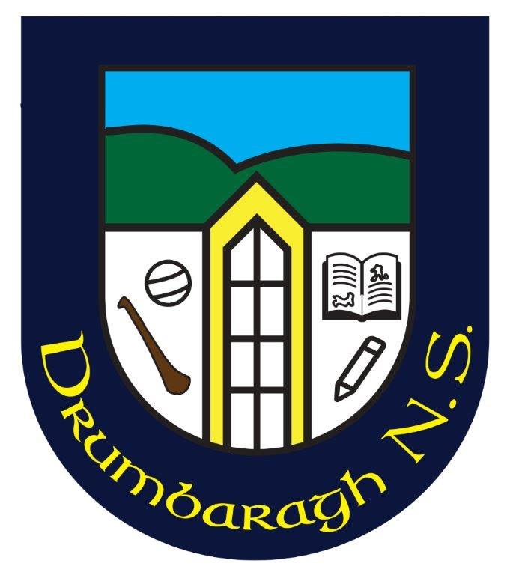
Healthy Eating Policy
Drumbaragh National School, Drumbaragh, Kells, Co. Meath A82NP98
Roll Number: 10801Q

The school day provides the opportunity for having at least one of the daily meals within the school. HSE Healthy Lunch Project Evaluation states that ‘the school setting is deemed to be one of the most effective and efficient ways to reach large populations, including young people, school personnel, families and community members.
Our SPHE policy promotes healthy living and healthy lifestyles. Healthy Eating forms a significant portion of a healthy lifestyle. The school is committed to promoting healthy eating through enabling the pupils to achieve formal SPHE objectives. The school acknowledges that school lunches are a means by which healthy eating may be practiced.

Aim
The aim of the Healthy Eating Policy is to encourage children to have a lunch which contains a wide variety of nourishing food which will contain the energy and nutrients required to stay healthy.

Healthy Eating Guidelines
- Parents should ensure that children have a balanced breakfast to help them learn and concentrate better in school.

- A healthy lunchbox includes a helping of food from the bottom four shelves of the food pyramid.

- Some of the healthy snacks that we encourage include fresh fruit, vegetables, cheese, standard yoghurts (non-dessert), plain rice cakes and crackers.

- All pupils are encouraged to bring plain milk to school. Milk is an excellent source of calcium which is the main mineral present in bones and teeth. For children aged 9-18 years, 5 servings of calcium rich foods are recommended due to the importance of this mineral during this life stage.
- Tap water will be made available throughout the day/ Pupils are encouraged to bring a bottle of tap/still water to school. If children do not drink enough water, they may become dehydrated, thirsty, tired and weak.
- Chocolate spreads, peanut butter, chocolate / cheese dips and chewy /sticky bars, sweets, chocolate, chewing / bubble gum, nuts, crisps, cereal bars, biscuits, pastries, fizzy drinks and juice drinks are not permitted.

- In line with the school's effort to make children environmentally aware and to reduce waste, we encourage pupils to cut down on needless packaging through selecting products with little packaging and using a lunch box to contain their lunch. Pupils are asked to take home lunch litter.
- On special occasions (decided on by the school) food related treats will be provided.

- Nutrition & healthy eating will be included as part of the school curriculum.

- Teachers and staff will provide positive support to encourage healthy eating including providing non-food related rewards.

- ‘Healthy Eating Awareness Days’ will be held each term as an incentive to encourage healthy eating at school and at home.

- The 'Healthy Eating Guidelines' will be reviewed every two years and the policy will be visibly displayed in the school.

Action Plan
- Parents / Guardians and where applicable, the pupils themselves, will be asked to prepare lunches which are healthy and in line with the school Healthy Eating policy
- The school will distribute healthy eating / oral health leaflets eg: healthy lunchbox leaflet, food pyramid, food shopping card, snack right smile bright, best drinks for smart kids etc
- School staff will promote healthy eating in the school through commending pupils who take healthy lunches to school.
- School staff will promote healthy eating in the school by providing learning experiences, primarily through the SPHE and SESE Science curriculum, for all pupils on healthy eating.
- The school is planning on joining the Health Promotion Programme next year.

Role of School Staff
Teaching and non-teaching staff will guide the pupils regarding healthy lunch items. It is not the role of teaching and non-teaching staff to ‘police’ lunches, however, teaching staff may ‘check- in’ with pupils on a regular basis to ensure healthy lunches are brought to school.

Eating and non-eating of lunches.
All pupils will be given their full allocation of eating time to eat their lunches. It is not the role of teaching and non-teaching staff to ‘police’ lunches. If pupils are hungry enough, they will eat. If a pupil eats a minimal lunch, a parent / guardian should not be concerned. Such pupils can eat a good breakfast and a healthy after school snack to compensate.

